Capabilities Page
Banner section
Corporate Law & Strategic Advisory
Legal Counsel for the Decisions That Shape Your Business

Opening Paragraph
Strategic legal advice for businesses operating across governance, ownership, restructuring, complex transactions, and the decisions that shape their future direction.
Why This Matters
Businesses rarely make decisions with purely legal consequences.
A change in ownership, a corporate reorganisation, a strategic investment, a new partnership, or a significant business decision can affect governance, control, risk, compliance, and the organisation's future flexibility.
The right legal advice helps leadership teams understand these implications before decisions are made and not after problems emerge.

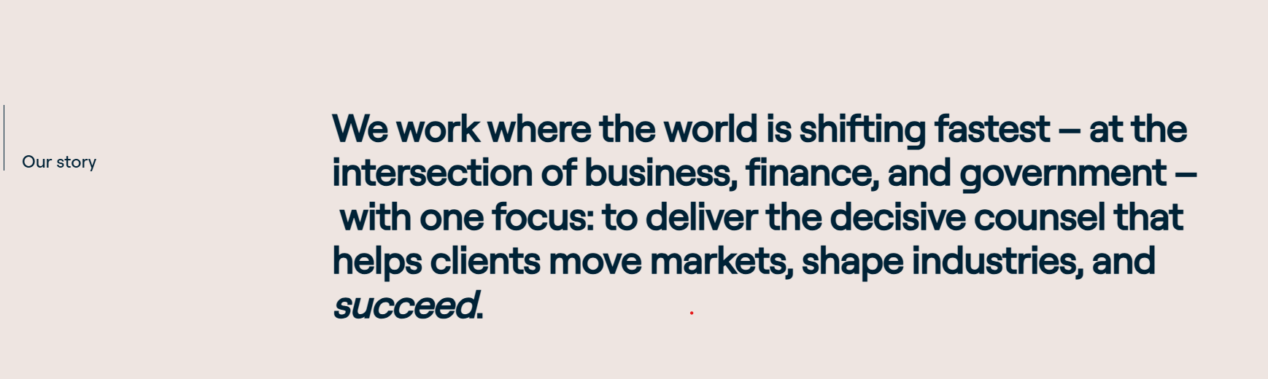

When You Need Legal Counsel [on left side]
Strategic legal counsel can be valuable when your business is: [on left side]
[on right side] text animation
- changing its ownership or corporate structure;
- considering a corporate reorganisation or restructuring;
- evaluating an investment, acquisition, joint venture, or strategic partnership;
- managing complex shareholder, board, or governance matters;
- making decisions with significant legal, business, or regulatory implications; or
- seeking ongoing senior legal input without adding a full-time General Counsel.



Who We Support
We support SMEs, growth-stage businesses, established enterprises, family-owned and promoter-led businesses, and leadership teams that need experienced legal counsel without the cost or commitment of building full-time in-house capacity.

How We Help You
We help leadership teams navigate the legal dimensions of decisions that affect ownership, control, governance, growth, risk, and long-term business direction.
- Corporate structuring and reorganisations
- Corporate restructuring and strategic reorganisations
- Governance and board advisory
- Shareholder arrangements and shareholder matters
- Strategic transactions and investments
- Joint ventures and strategic collaborations
- Regulatory alignment
- Ongoing strategic legal support

Our Perspective
Good legal advice does more than identify legal issues. It helps businesses understand their implications, evaluate their options, and make informed decisions.
Our role is to help leadership teams consider legal issues within the broader context of the business bringing legal perspective to decisions shaped by commercial objectives, governance considerations, risk, and the organisation's long-term direction.


Our Perspective left side on the picture and content on the right side on the colour shape
Or


Selected Transactions & Advisory Matters
JOINT VENTURE & TECHNOLOGY TRANSFER | INDIA / SWITZERLAND
Advised a listed Indian company on a joint venture with a Swiss entity involving transfer of proprietary technology for the manufacture of specialised substrates under the ‘Make in India’ initiative for supply to a government authority.
AGRICULTURAL TECHNOLOGY COLLABORATION | INDIA
Advised an Indian agricultural technology company on a proposed collaboration for the design and deployment of advanced seed treatment equipment.
SPORTS DEVELOPMENT COLLABORATION | INDIA
Advised the founder and Managing Director of a leading badminton training academy on a strategic partnership with a prominent Indian badminton coach and former international player, providing legal support for an initiative focused on promoting grassroots badminton development across India.
INFRASTRUCTURE INVESTMENT | INDIA
Advised an Indian infrastructure company on an investment from an infrastructure fund for acquisition of minority stake in a special purpose vehicle holding a portfolio of build-operate-transfer (BOT) road projects.
AVIATION ASSET ACQUISITION & FINANCING | INDIA / UNITED KINGDOM
Advised an international asset holding company on the acquisition of a Bombardier Global 5000 business jet, partially financed through a cross-border loan of US$26.5 million from a UK-based bank.
RENEWABLE ENERGY | INDIA
Advised and assisted an Indian renewable energy company on the sale of its 51% shareholding in a project company, through the exercise of tag-along rights alongside its joint venture partner.



